Matthew Gamboa   
Module 3.2  
4/7/24

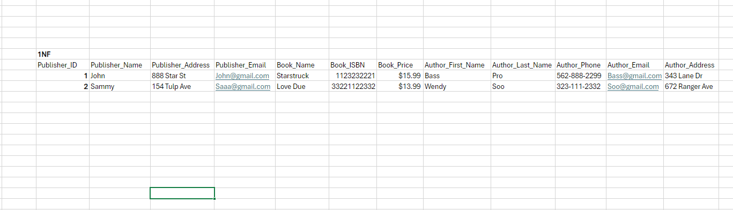

| **3NF** |  |  |  |  |  |
| --- | --- | --- | --- | --- | --- |
| Publisher Table |  |  |  |  |  |
| Publisher_ID | Publisher_Name | Publisher_Address | Publisher_Email |  |  |
|  |  |  |  |  |  |
| Book Table |  |  |  |  |  |
| Book_Name | Book_ISBN | Book_Price |  |  |  |
|  |  |  |  |  |  |
| Author Table |  |  |  |  |  |
| Author_First_Name | Author_Last_Name | Author_Phone | Author_Email | Author_Address |  |